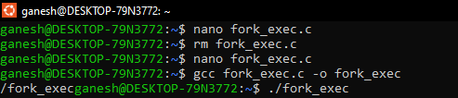

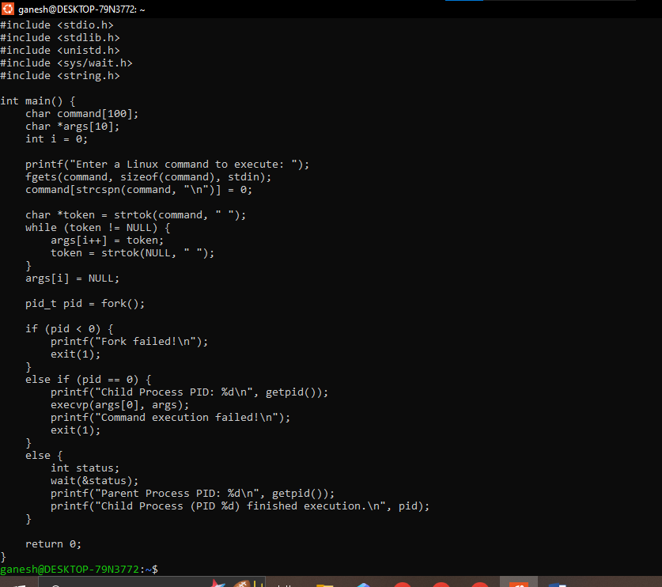
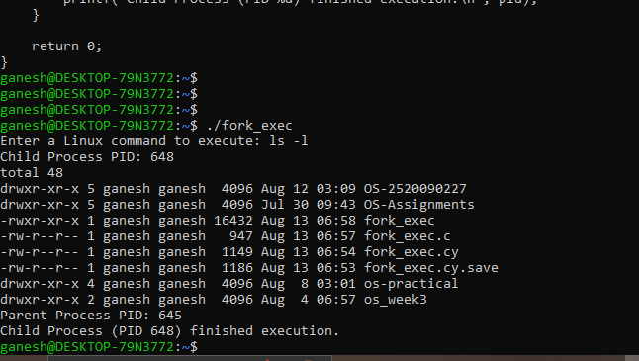

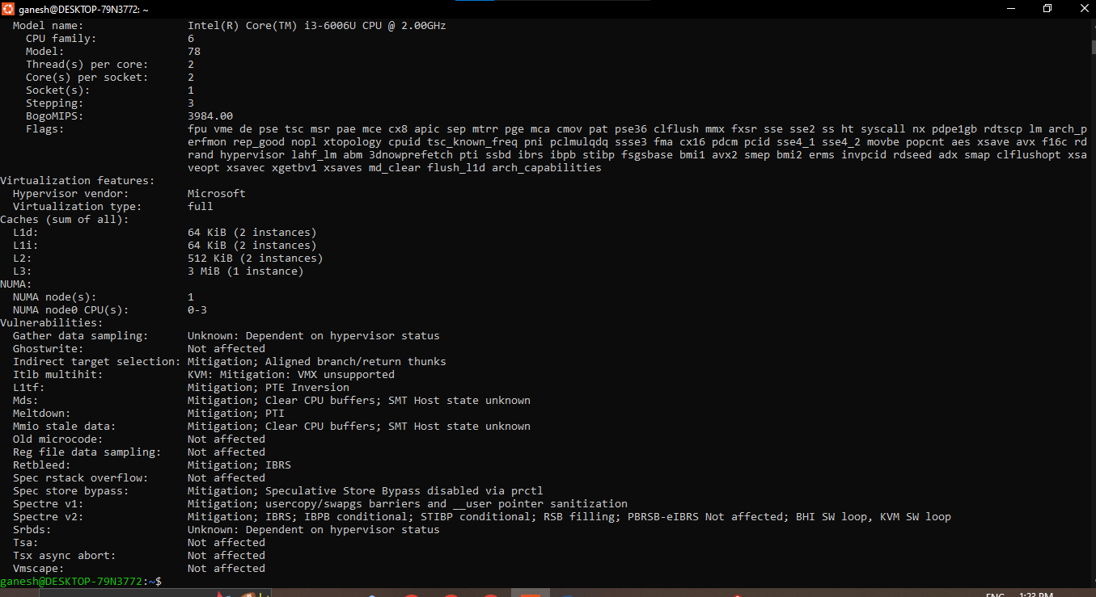
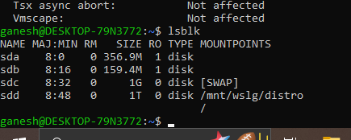
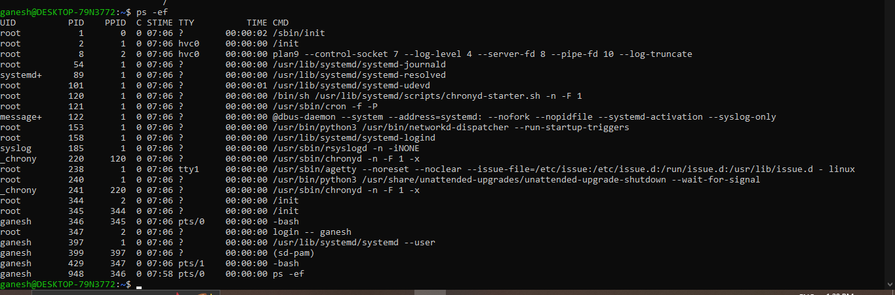
- Task 2 Analysis
Each Linux command reveals how the OS abstracts hardware for the user:
- uname -a → shows kernel version, hostname, and architecture — the OS layer between hardware and applications.
- lscpu → exposes CPU details (cores, architecture) that the OS schedules processes across, hiding physical core management from programs.
- lsblk → shows storage devices/partitions, how the OS abstracts raw disks into mountable filesystems.
- ps -ef → lists running processes, showing how the OS manages multitasking and memory allocation per process.
- top → shows real-time CPU/memory usage, how the OS dynamically allocates resources among competing processes.
Together, these prove the OS acts as a resource manager — abstracting CPU scheduling, memory, storage, and I/O so applications don't interact with hardware directly.

B) Result analysis
Task 1 demonstrated process creation and control using fork(), execvp(), and wait(), showing how a parent process spawns a child, replaces its image with a new command, and synchronizes execution. Task 2 showed how Linux terminal tools expose the OS's management of CPU, memory, storage, and running processes, confirming that the OS abstracts hardware complexity into simple, uniform interfaces for users and programs.

